Shopify Stock Data
Financial Data Import, Transformation & Time Intelligence
Week 3 – Documentation Report

Prepared using: Power BI Desktop
Name: Deepika J
Roll.no: E25DAOO8
Dept: B.Sc. DS and AI

Objective
The aim of this Week 3 exercise is to prepare Shopify stock market data for financial analysis in Power BI. The work focuses on date-based analysis, a dedicated Date Table, an active relationship between the Date Table and stock data, and financial measures for stock prices and trading activity.

Problem Statement
An investor wants to analyze Shopify stock performance over time and understand changes in stock prices and trading activity.

Tasks Covered
- Import and prepare Shopify stock data in Power Query.
- Create a dedicated Date Table for time-based analysis.
- Create an active one-to-many relationship between the Date Table and stock data.
- Create financial measures for Open Price, Close Price, High Price, Low Price, Trading Volume, and Daily Return %.
- Use date fields for time-based stock analysis and dashboard reporting.

Step 1: Preparing the Shopify Stock Data
The Shopify stock dataset was opened in Power Query Editor. The data contains financial fields such as high, low, close, adjusted close, volume, open, and date. A copy of the date column was created so that the date information could be used for further date-based transformations.
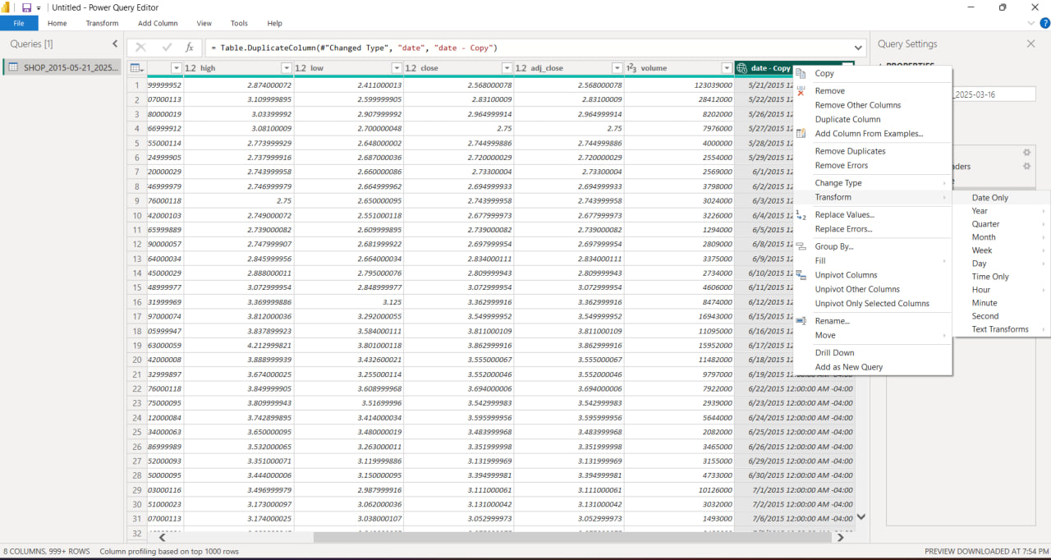
Figure 1: Shopify stock data in Power Query with the date column copied for transformation.

Step 2: Creating the Date Table
A separate Date Table was created in Power BI to support time-based financial analysis. The Date Table contains Date, Day, Month, Month Number, Quarter, and Year fields. These fields provide a structured way to analyze stock values across different time periods.
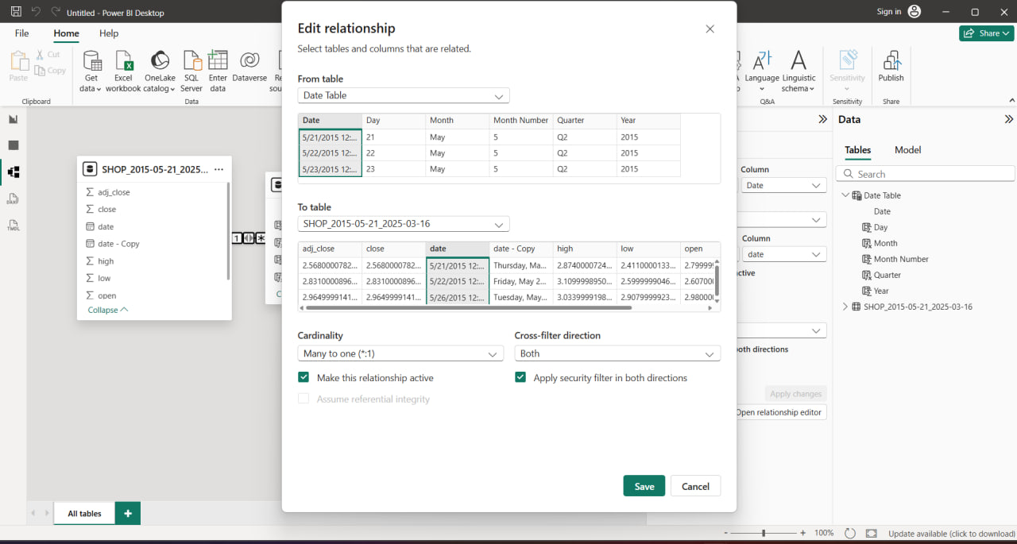
Figure 2: Date Table related to the Shopify stock data.

Step 3: Establishing the Date Relationship
An active relationship was configured between the Date Table and the Shopify stock table using the Date field. The relationship editor shown in the screenshot uses Date Table as the source table and the Shopify stock table as the related table, with a many-to-one relationship from the stock records to the Date Table.
The relationship is marked as active, allowing the Date Table to support filtering and time-based analysis of the stock data.

Step 4: Creating Financial Measures
Financial measures were created for the main stock indicators required for the dashboard. The report fields show measures for Open Price, Close Price, High Price, Low Price, Trading Volume, and Daily Return %. These measures are used to present key stock information and support financial analysis.

Step 5: Building the Stock Dashboard
The final Power BI page combines KPI cards, time-series charts, trading volume, daily return, and a Year-Month date slicer. The dashboard includes Open Price by Date, Close Price by Date, Close Price, High Price, Low Price, Open Price, Trading Volume by Date, and Daily Return % by Date.
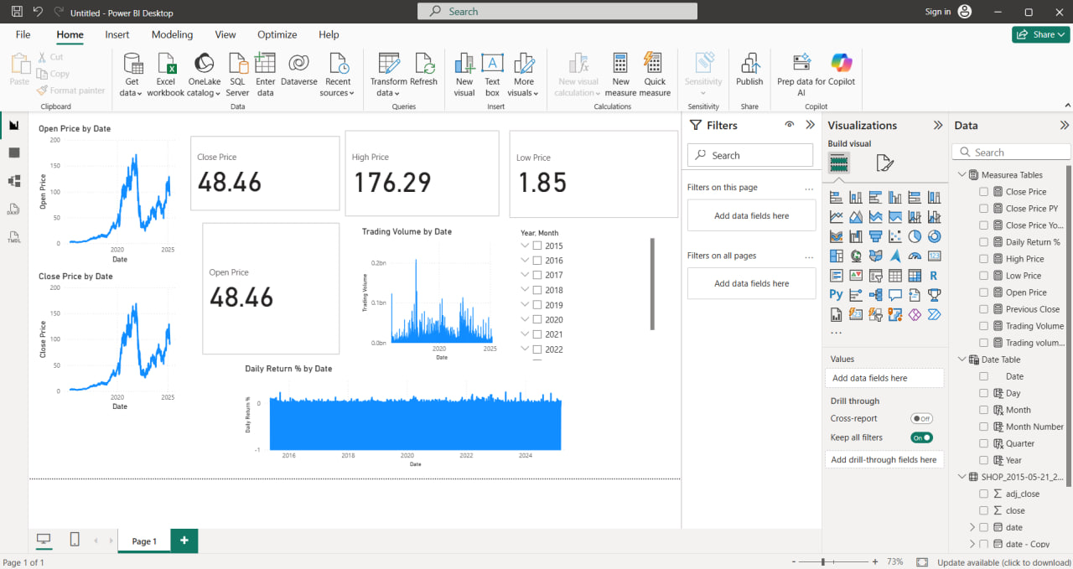
Figure 3: Final Shopify stock analysis dashboard.

Final Output
The final dashboard displays the following visible KPI values and visual outputs: Close Price of 48.46, High Price of 176.29, Low Price of 1.85, and Open Price of 48.46. It also provides time-series views for stock prices, trading volume, and Daily Return %, together with Year-Month filtering.

Conclusion
During Week 3, the Shopify stock dataset was prepared in Power BI and organized for financial time-series analysis. A dedicated Date Table was created and linked to the stock data through an active relationship. Financial measures for the main stock indicators were used to build a dashboard containing KPI cards, time-series charts, trading volume, Daily Return %, and date-based filtering. The completed dashboard provides a structured view of Shopify stock performance over time.

